

Book Discussion



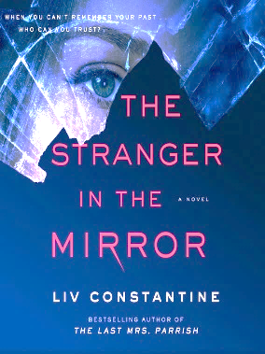

**The Stranger in the Mirror**

**by Liv Constantine**

**Wednesday, June 12**

Addison’s about to get married, but she’s not looking forward to the big day. It’s not her fiancé; he’s a wonderful man. It’s because Addison doesn't know who she really is. A few years ago, a kind driver found her bleeding next to a New Jersey highway and rescued her. While her physical wounds healed, Addison’s memory never returned. She doesn’t know her real name. Or how she ended up injured on the side of a road. Or why she can’t shake the notion that she may have done something very, very bad . . .

In a posh home in the Boston suburbs, Julian tries to figure out what happened to his loving, caring wife, Cassandra, who disappeared without a trace two years ago. She would never have left him and their seven-year-old daughter Valentina of her own free will—or would she?

As these two lives intersect, The Stranger in the Mirror hooks readers with riveting drama, told with Liv Constantine’s hallmark blend of glamour, tense psychological thrills, and jaw-dropping twists.

**6 – 7 pm**

**If you’d like to participate, please, call the library at 724-523-5702.**

**Books will be available for pick-up by Wed., May 8.**

**Keep checking our Facebook and Instagram.**

**I’ll post when the books arrive.**